Why Calling & Video Calling Is Critical for Your Target Users
For school + early college students, calling/video is not just “interview tech” — it is a skill-development tool.
Human skills you are targeting:
- Communication clarity
- Leadership & persuasion
- Confidence & body language
- Emotional intelligence
- Team collaboration

Calling & Video Calling Use-Cases (Very Important)
🎯 1. 1-to-1 Mentorship Calls
- Student ↔ Mentor / Industry expert
- Career guidance
- Soft-skill feedback
- Confidence building
🎯 2. Mock Interviews (Audio + Video)
- HR-style interviews
- AI cannot replace this human feedback loop
- Recording for self-review
🎯 3. Group Discussions (3–8 students)
- Leadership emergence
- Speaking order discipline
- Peer learning
Best Technology Options (Industry-Proven)
🔹 Option A: WebRTC (Recommended for Long Term)
Best if you want control and scalability
Stack:
- WebRTC (real-time audio/video)
- STUN / TURN servers
- Signaling via Firebase / Socket.IO
Pros
- No per-minute cost
- Full control
- Scales well
Cons
- Higher development effort
Twilio Video / Agora (Fastest to Launch)
Best for MVP
Why ideal for students?
- Stable on low bandwidth
- Mobile friendly
- Built-in recording
Provider | Best Use
Twilio | Professional interviews
Agora | Education + group calls
Jitsi (Self-hosted) | Budget friendly
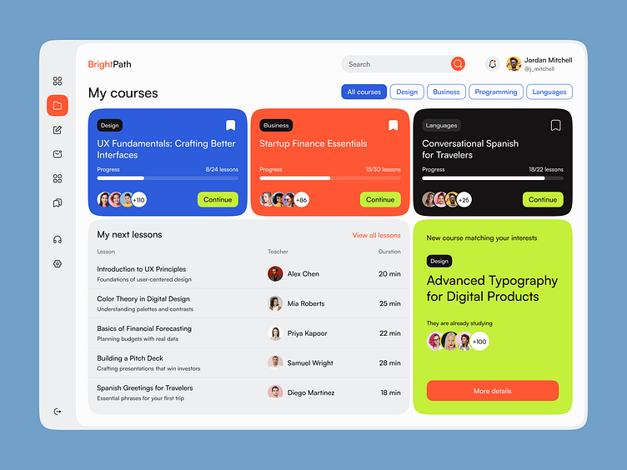
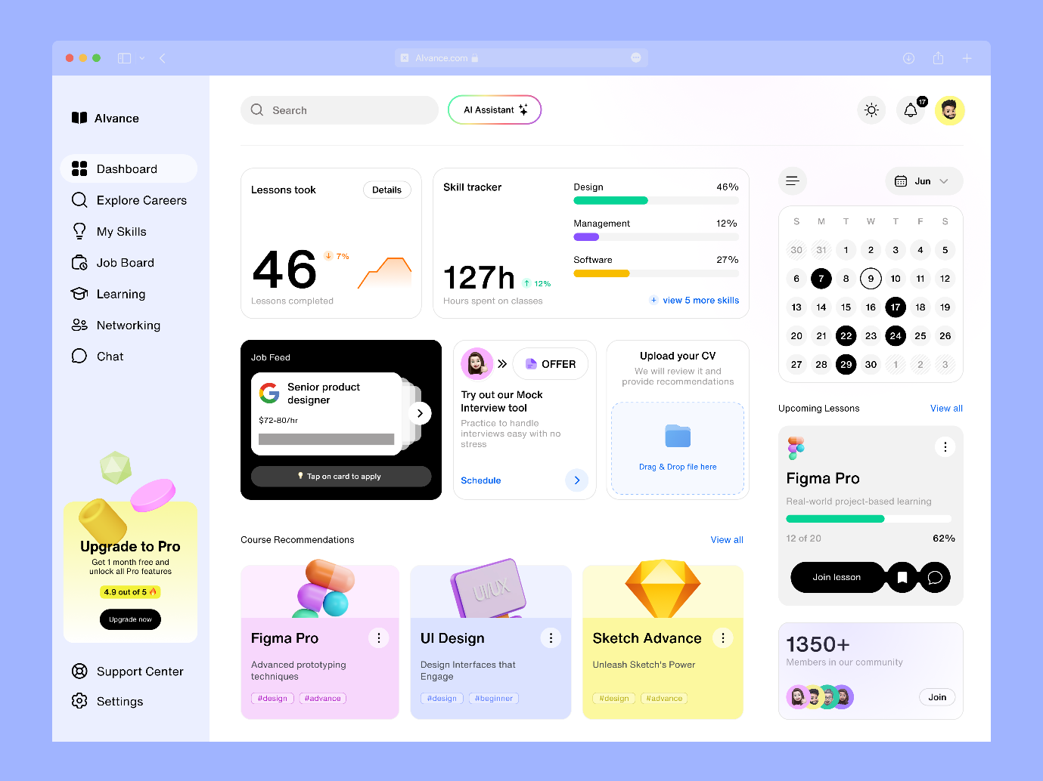
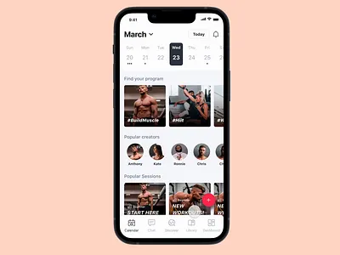

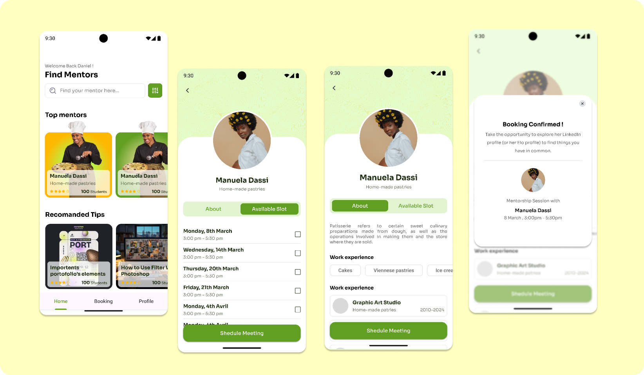

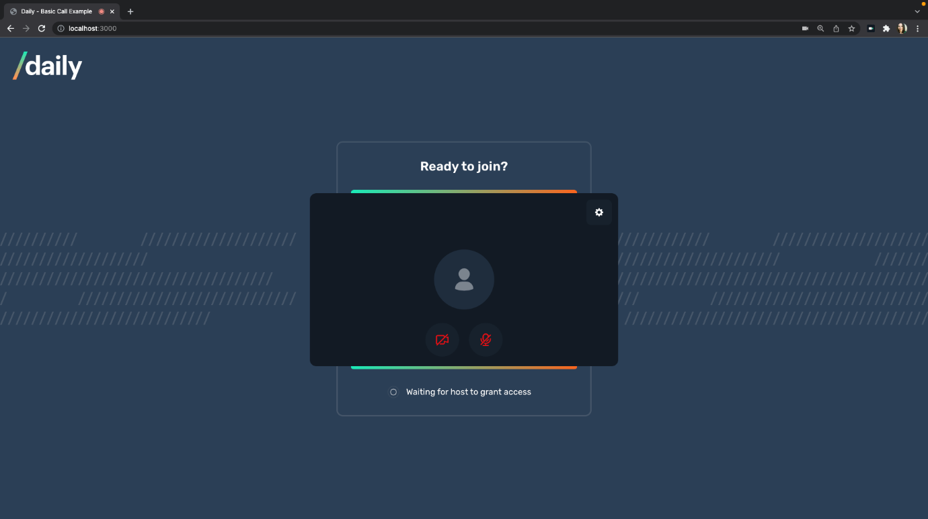
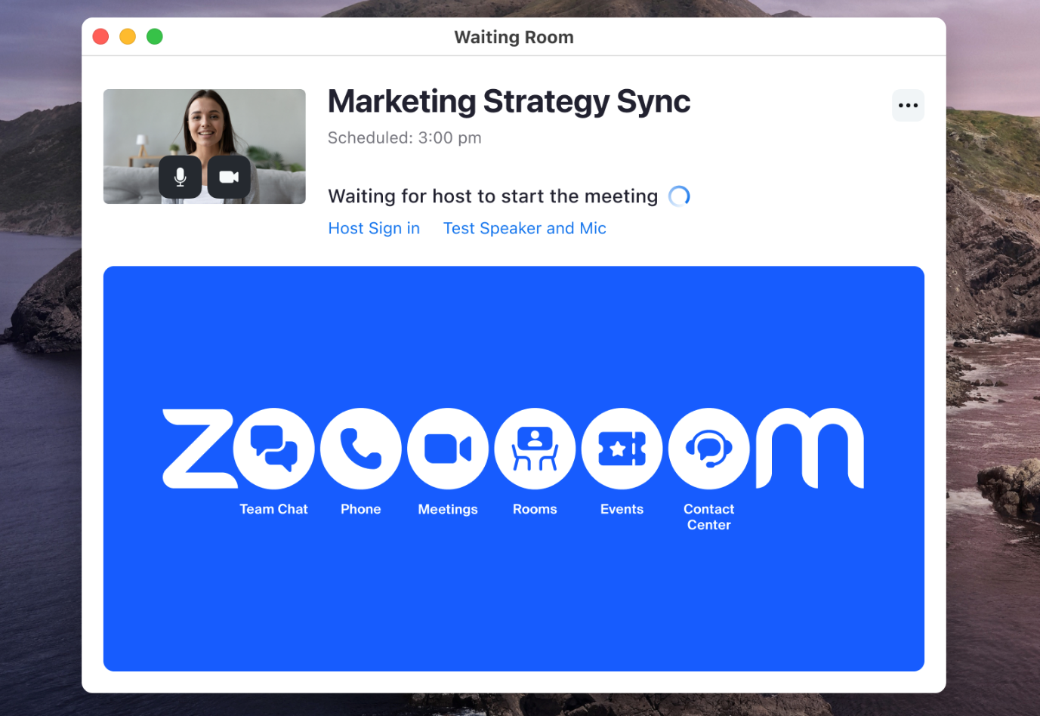
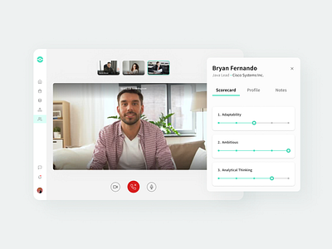
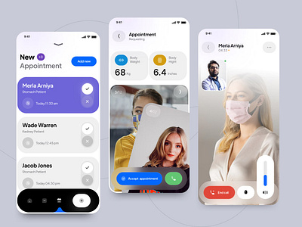
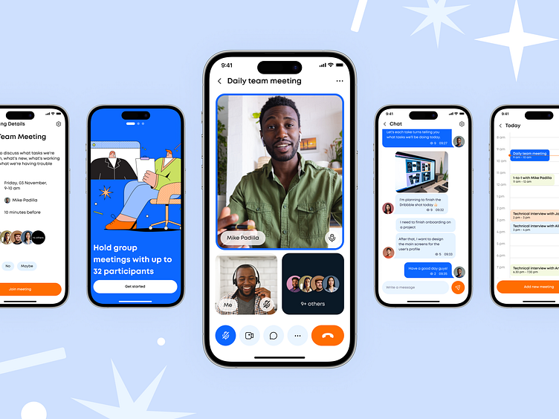

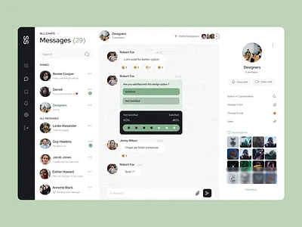
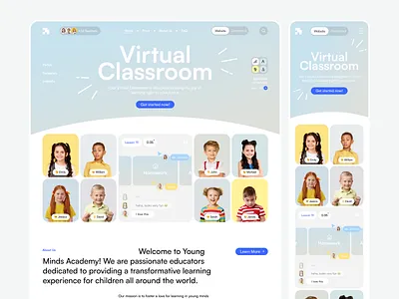
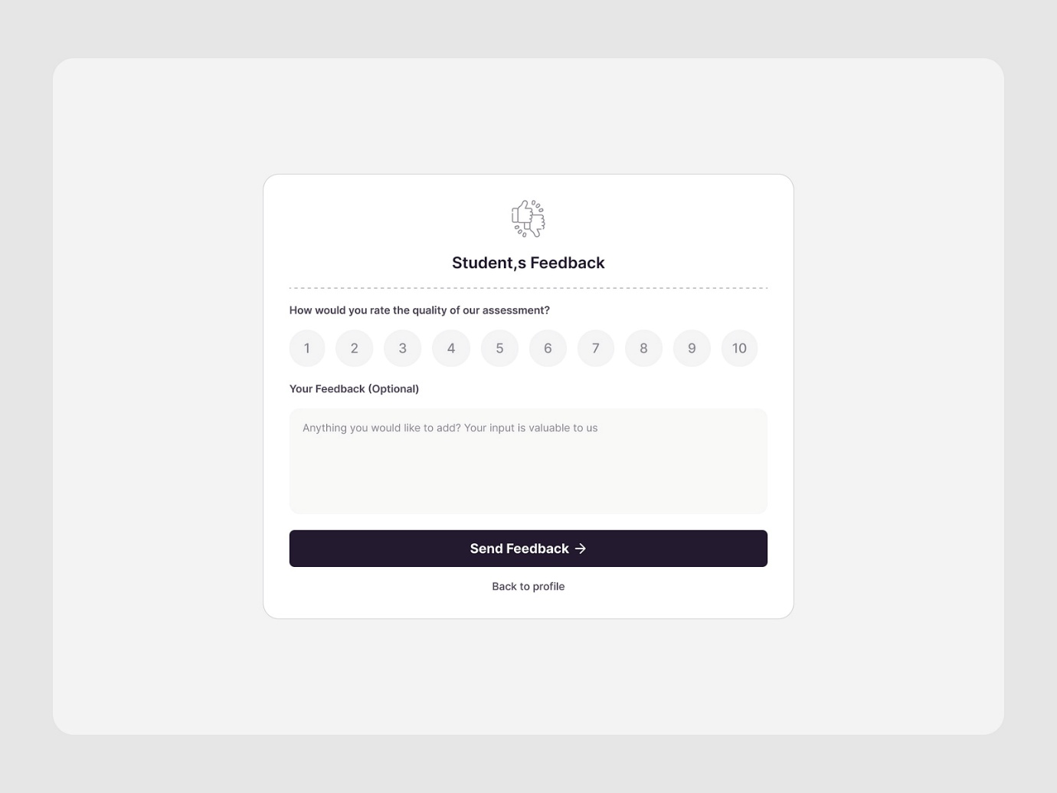
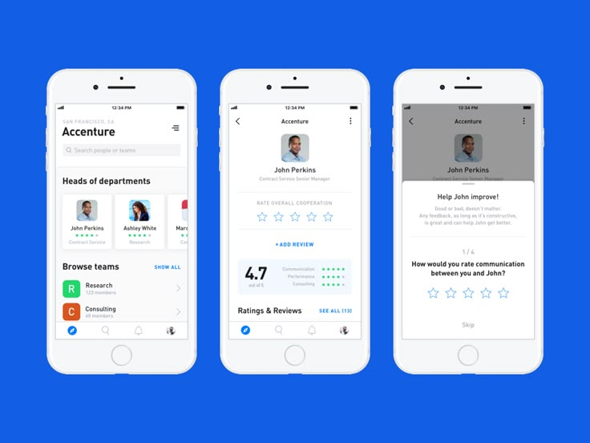
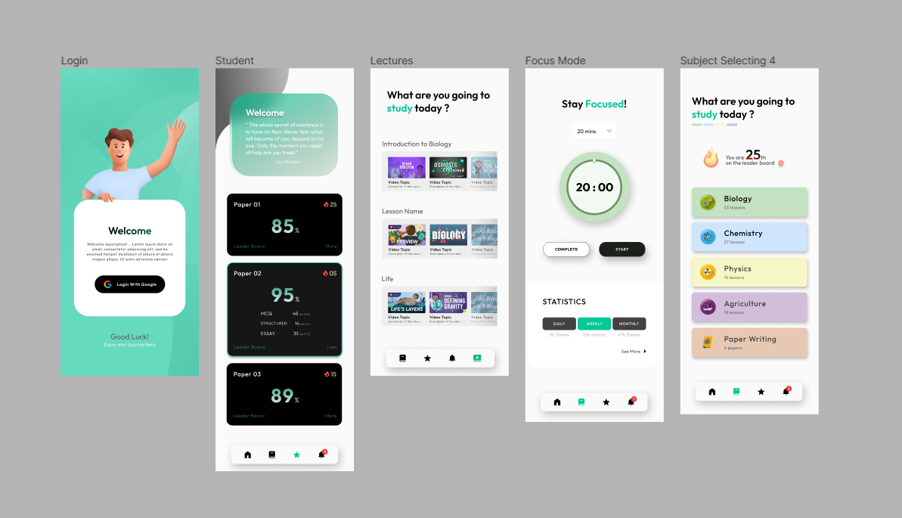
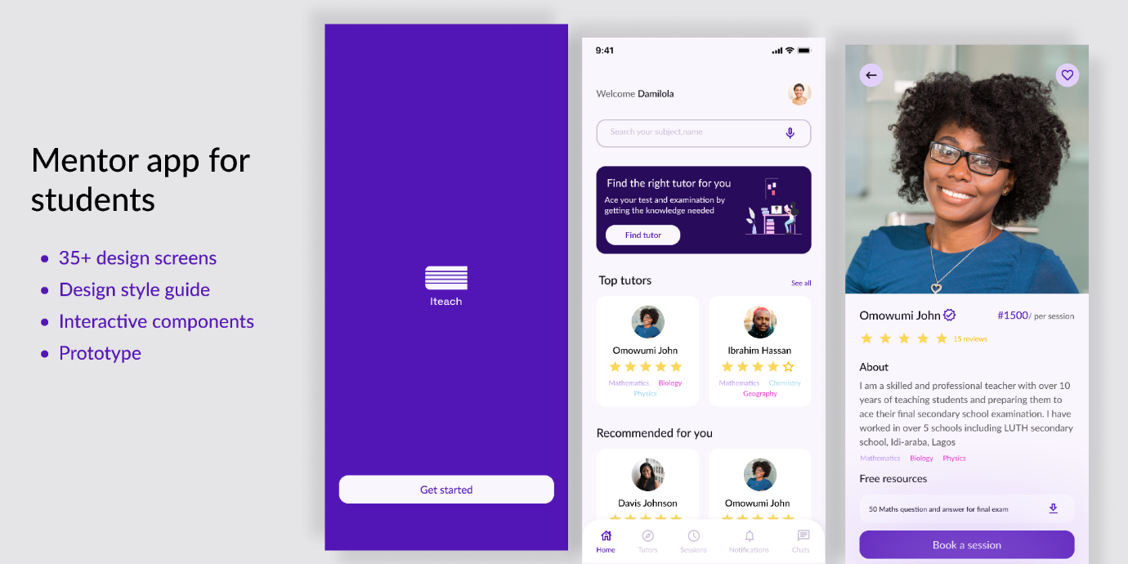
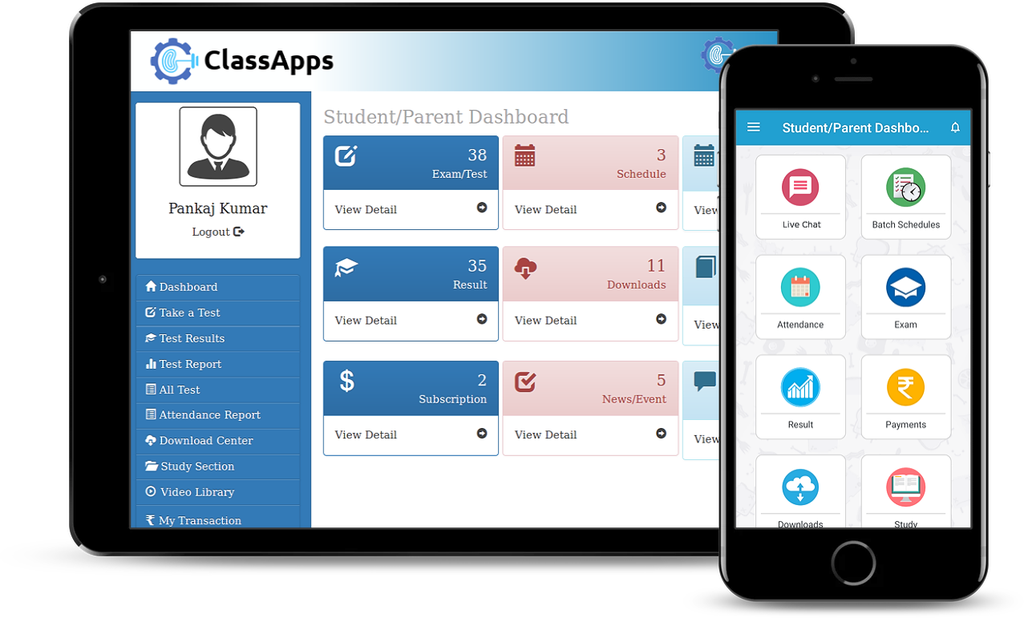

🔰 PART 1: WHAT THESE APPLICATIONS ACTUALLY ARE (BASICS)
You do NOT install Agora or Twilio like a normal app.
They are communication platforms (SDKs + cloud services) that you connect to your own application.
🧠 What Problem They Solve
Without them, you would need to:
- Build real-time audio/video
- Handle low internet
- Manage call quality
- Handle recording
- Handle security
This is extremely complex.
👉 Agora/Twilio already solved this, you just “plug” them in.

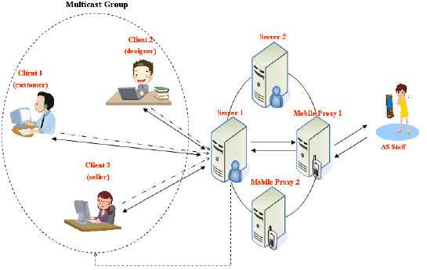
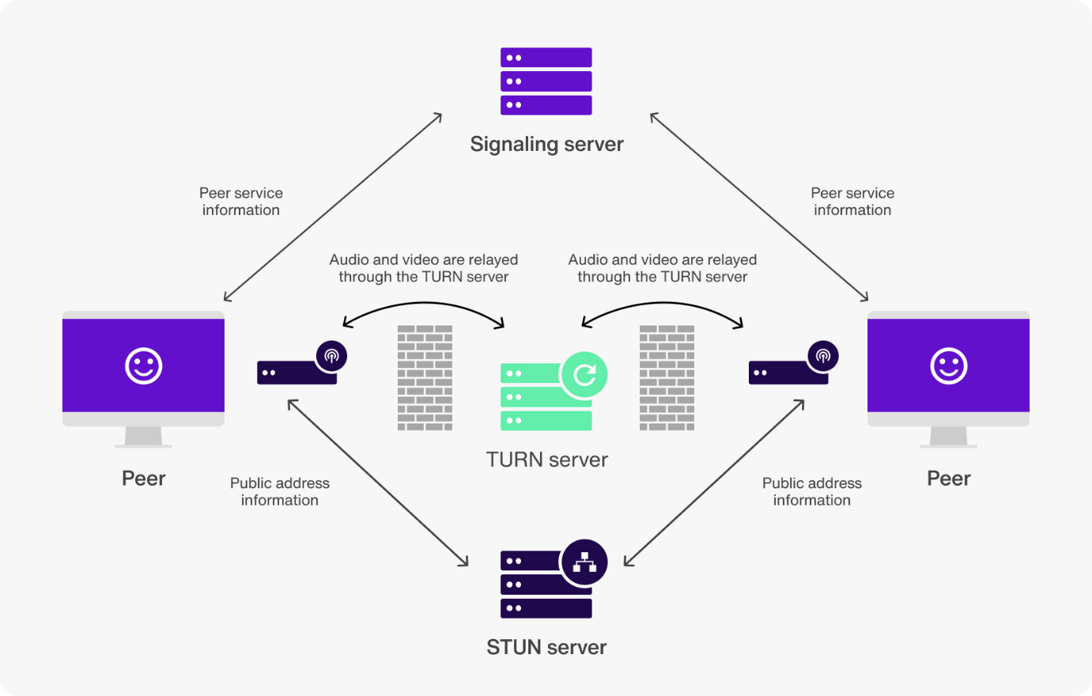
Call Flow (Simple)
- Student clicks Join Session
- Your backend creates a secure token
- App connects to Agora/Twilio servers
- Audio/Video flows directly between users
- Your app only controls UI + permissions
Your server does NOT carry video data → saves cost & load.

Feature | Agora | Twilio
Learning curve | Easier | Moderate
Cost | Lower | Higher
Education focus | Excellent | General
Low bandwidth | Very strong | Good
Group calls | Easy | Slightly complex

PART 3: BASIC TERMINOLOGY (MUST UNDERSTAND)
1️⃣ App ID
- Like your project identity
- Created in Agora/Twilio dashboard
2️⃣ Channel Name
- Think of it as meeting room ID
- Example: mock_interview_1023
3️⃣ Token
- Temporary key (security)
- Prevents random users joining calls
- Generated by your backend
⚠️ Never hardcode tokens in frontend
PART 4: STEP-BY-STEP – ADDING AGORA TO YOUR PROJECT
I’ll assume Flutter, but logic is same for React/Android/iOS.

STEP 1️⃣ Create Agora Account (Once)
- Go to Agora website
- Sign up
- Create a New Project
- Copy:
  - App ID
  - Enable Audio + Video
  - Set authentication = Token
You now have your “engine”.

STEP 2️⃣ Install Agora SDK in Flutter
dependencies:
agora_rtc_engine: ^6.3.0
STEP 3️⃣ Permissions (MANDATORY)
Android
<uses-permission android:name="android.permission.RECORD_AUDIO"/>
<uses-permission android:name="android.permission.CAMERA"/>
iOS
NSCameraUsageDescription
NSMicrophoneUsageDescription

STEP 4️⃣ Basic Agora Initialization (Beginner Level)
final engine = createAgoraRtcEngine();

await engine.initialize(
RtcEngineContext(
appId: "YOUR_APP_ID",
),
);
This does NOT start a call.
It only prepares the engine.

STEP 5️⃣ Join Audio Call (Student-Friendly Default)
await engine.joinChannel(
token: tokenFromBackend,
channelId: "mock_interview_1023",
uid: 0,
options: ChannelMediaOptions(
channelProfile: ChannelProfileType.channelProfileCommunication,
),
);
🎯 This gives:
- Audio call
- Low bandwidth
- Works even on weak networks

STEP 6️⃣ Enable Video (Only If Student Chooses)
await engine.enableVideo();
This is why Audio-first UX is perfect for your audience.

🧑‍🎓 PART 5: HOW THIS FITS INTO YOUR EXISTING JOB PORTAL
Existing Modules You Already Have
- Users (students, mentors)
- Booking system
- Notifications
What You ADD
New Table | Purpose
sessions | Stores call info
session_participants | Student + mentor
session_feedback | Skill ratings

📊 Example Session Record
{
"session_id": "S1023",
"type": "mock_interview",
"mode": "audio",
"channel": "mock_interview_1023",
"mentor_id": "M12",
"student_id": "U45",
"status": "completed"
}

🔐 PART 6: TOKEN GENERATION (ADVANCED BUT CRITICAL)
⚠️ Never generate tokens in frontend
Backend (Node example)
const RtcTokenBuilder = require('agora-access-token');

const token = RtcTokenBuilder.buildTokenWithUid(
APP_ID,
APP_CERTIFICATE,
channelName,
uid,
role,
expireTime
);
Frontend calls:
GET /generate-token?channel=mock_interview_1023

🧠 PART 7: ADVANCED FEATURES YOU CAN ADD LATER
🔹 Call Recording
- Useful for student review
- Paid feature
🔹 Network Adaptation
- Auto downgrade to audio
🔹 Call Timer + Auto End
- Prevent misuse
🔹 Mentor Feedback Lock
- Feedback mandatory after call

🛡️ PART 8: SAFETY & COMPLIANCE (VERY IMPORTANT FOR STUDENTS)
✔ Session duration limit
✔ Report user button
✔ Audio-only default
✔ No recording without consent
🧠 MENTOR ROLE IN YOUR SYSTEM (BASIC CONCEPT)
A mentor can:
- Accept / reject sessions
- Join calls
- Control call flow
- Give structured feedback
- Close sessions properly
They cannot:
- Join random calls
- Extend time without permission
- Record without consent

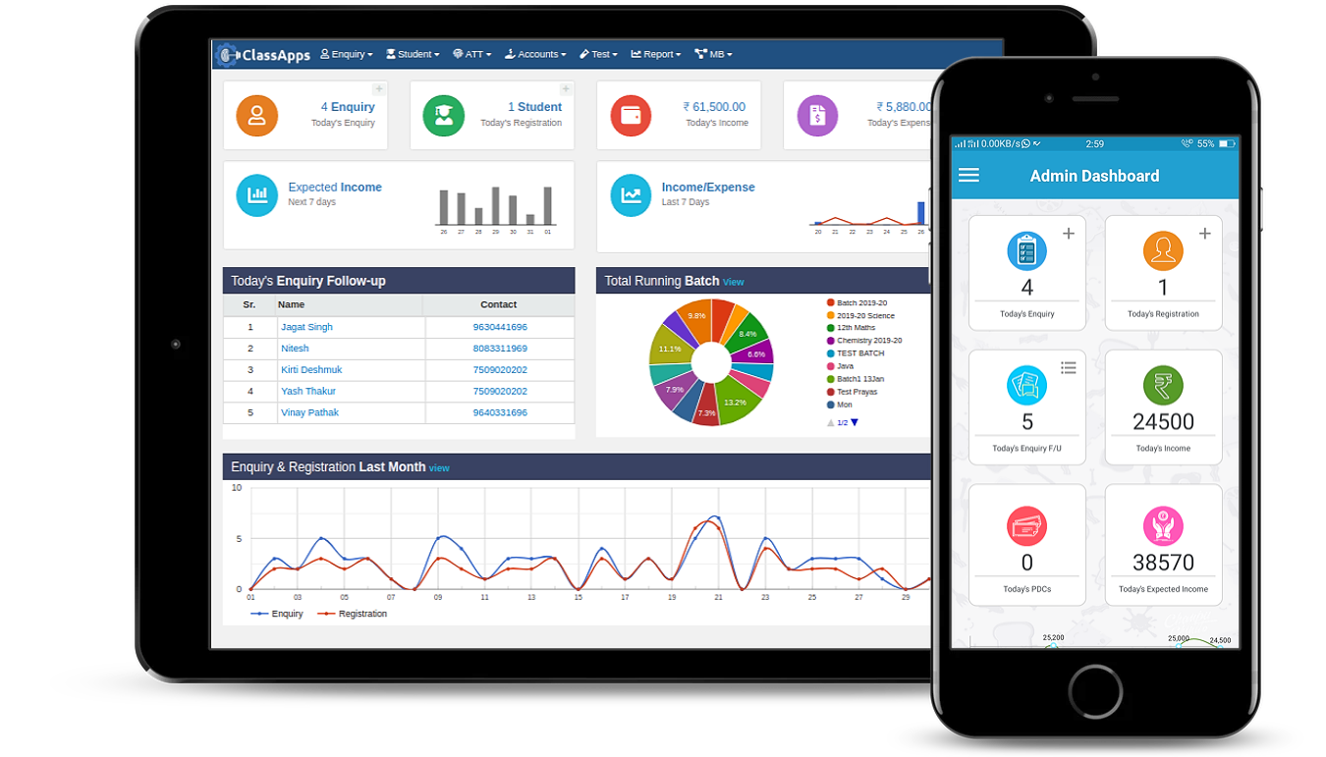
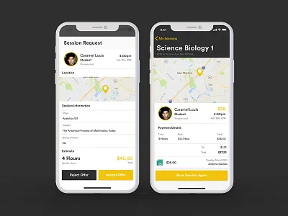
Details shown
- Student name + education level
- Session type (Mock Interview / Mentorship)
- Mode (Audio / Video)
- Duration
- Skill focus (Communication, Leadership)
Buttons
- ✅ Accept
- 🔁 Reschedule
- ❌ Reject (reason mandatory)

Purpose: Prepare mentor before joining
UI Components
- Student summary card
- Session rules reminder
- Mic / Camera test
- Countdown timer
CTA
- Start Session

🧱 BACKEND LOGIC (VERY IMPORTANT)
Session Table (Extended)
{
"session_id": "S1023",
"mentor_id": "M12",
"student_id": "U45",
"role": "mentor",
"status": "scheduled",
"start_time": "2026-02-04T10:00",
"end_time": "2026-02-04T10:30",
"channel": "mock_interview_1023"
}
Token Generation (Mentor = Host)
const role = RtcRole.PUBLISHER; // Mentor
Student token:
const role = RtcRole.SUBSCRIBER;
This gives mentor control authority.

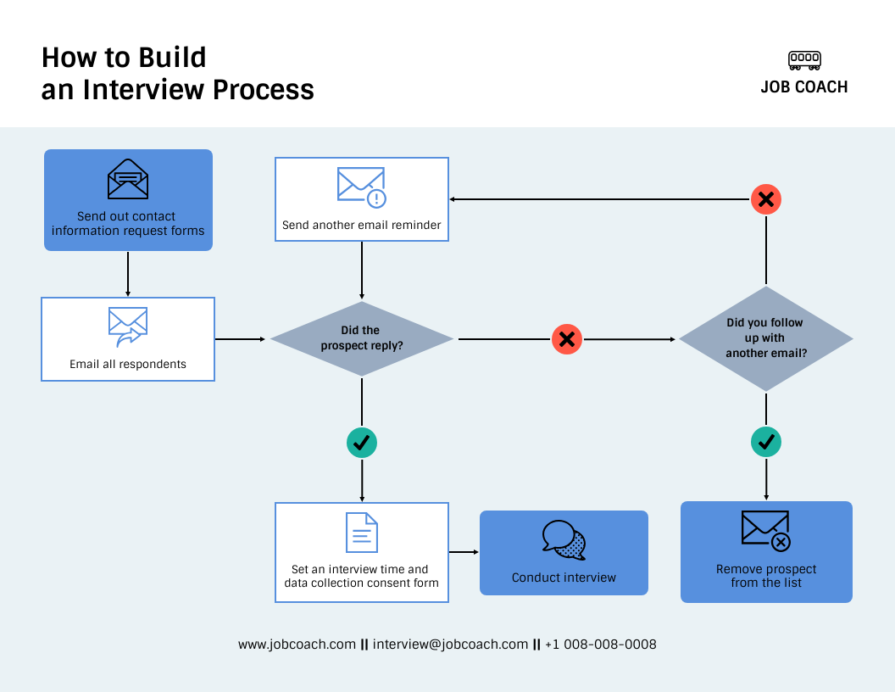
Step-by-step
- Mentor accepts session
- Backend locks time slot
- Mentor clicks Start Session
- Token generated (mentor role)
- Student allowed to join
- Call auto-ends on timer
- Feedback screen opens

🎯 Why Use a Platform Like Agora
Platforms such as Agora or similar SDKs are not standalone apps — they are backend services that power real-time video/voice features inside your own app. They handle:
- Reliable audio/video transport over the internet
- Low latency (minimal delay)
- Adaptive quality on poor networks
- Cross-platform support (Android/iOS/Web)
- Security, scaling, and global coverage
All of that is extremely non-trivial to build yourself. Using an SDK lets your developers focus on feature logic (booking, mentoring, feedback) instead of building and maintaining video streaming infrastructure.

📌 Main Alternatives to Agora
Below are some popular options you can choose from — each with pros and cons:
🧑‍💻 1. Twilio Video
- Enterprise-grade real-time SDK
- Easy integration + strong documentation
- Includes recording, analytics options
- Often chosen when you’re already using Twilio for SMS/OTP
- Pricing: Pay-as-you-go, about $0.004 per participant per minute for video calls (plus credits for recordings and additional features)
👉 Suitable if you want multi-channel communications (SMS, voice, video) from one provider.
🆓 2. Jitsi (Open Source)
- Free, open-source WebRTC platform
- No usage fees — you host it yourself
- Complete control over servers and privacy
❗ However: You must manage infrastructure yourself, handle scaling and maintenance, which adds engineering effort.
👉 Suitable if you have a backend team and want cost savings long-term + full control.
📊 3. Daily.co
- Simpler API with built-in prebuilt UI components
- Good for fast development
- Free tier and usage-based pricing with up to 10,000 free minutes
👉 Easy choice for quick proof-of-concept without heavy customization.

📶 4. Vonage Video API
- Another cloud real-time platform
- Competitive pricing (e.g., about $0.00395 per participant per minute)
👉 Good for scalable video with decent global support.
📡 5. Other Options
- ZEGOCLOUD — strong low-latency focus and built-in UI kits
- Zoom Video SDK — familiar video tech, but may be costlier and more focused on conferencing scenarios
- Self-hosted WebRTC frameworks (LiveKit, Mediasoup) — full control, but heavy dev effort

Provider | Video Call | Audio-only | Free Tier
Agora | ~$3.99 per 1,000 min (~$0.00399/min) | ~$0.99 per 1,000 min (~$0.00099/min) | 10,000 min free/month (Agora)
Twilio Video | ~$0.004 per participant per min | n/a standalone | Free trial credits (Twilio)
Daily.co | ~$0.004 per participant per min | n/a | 10,000 min free/month (Banuba)
Vonage Video API | ~$0.00395 per participant min | n/a | Depends on plan (Vonage)
Jitsi (self-hosted) | Free (you host infra) | Free | Free (Jitsi Support)
👉 Estimate example:
If you have 100 students doing 10-minute sessions monthly:
- 100 × 10 = 1000 participant minutes
- At Agora’s ~$0.00399/min → ~ $4 per month for video minutes (before free tier)
Costs grow with usage. Free tiers help for initial testing.
🌐 What is WebRTC? (Plain English)
WebRTC = Web Real-Time Communication
It is a technology standard that allows:
- Audio calls
- Video calls
- Screen sharing
- Real-time data
👉 Directly between users, inside apps or browsers, without downloads or plugins.
In simple words:
WebRTC lets two (or more) devices talk to each other live over the internet.
🧠 Real-World Examples You Already Know
WebRTC powers:
- Google Meet
- WhatsApp calls (partially)
- Zoom (core concepts)
- In-app video interviews
- Online classrooms
Your student ↔ mentor live session is exactly this.

